TRADE VISTA

Group Members

1. Mohammed Sareem Ahmed

2. Amandeep Kaur

3. Drishya Bhatt

4. Krishna Pandya

PROG8750 and Capstone Project

Semester Four

Submitted to

Pankaj Bains

TRADE VISTA

Introduction

The purpose of this project is to create a complete e-commerce website that is similar to Amazon in order to meet the growing demand for online shopping platforms. Users will be able to explore, search, and buy a variety of products from different merchants on the platform with ease and convenience.

Why This Project

The goal of this project is to develop a flexible and scalable online marketplace that benefits both customers and sellers. Benefits include creating an online marketplace, encouraging entrepreneurship, and providing consumers with a one-stop shop for all of their needs.

Design and Data Flow

Design:

1. Homepage: Including categories, promotions, and highlighted goods.
2. Product Pages: Comprehensive listings that include pictures, descriptions, costs, and seller details for every product.
3. User accounts: enabling registration, profile management, and order history tracking for users.
4. Seller Dashboard: Giving merchants the ability to control their orders, inventory, and product listings.
5. Admin page: Control User, Products and categories.
6. Shopping Cart: A feature for users to add, remove, and purchase items.

Data Flow:

* The user browses the user interface, performs product searches, and adds goods to the shopping cart.
* Order information is transferred to the backend after being processed by the frontend server.
* Relational databases are used to store user and product data.
* Order notifications are sent to sellers, who then get everything ready for shipping.
* Users may monitor the status of deliveries and receive real-time order updates.
* Updates to user profiles and completed orders are recorded in the database.

ER Diagram:

User Table:

* Fields: UserID (Primary Key), Username, Email, Password
* Relationships: One-to-Many with Orders (One user can place multiple orders)

Product Table:

* Fields: ProductID (Primary Key), SellerID (Foreign Key), ProductName, Description, Price, Stock
* Relationships: Many-to-One with Seller (Many products can belong to one seller), One-to-Many with Orders (One product can be in multiple orders)

Order Table:

* Fields: OrderID (Primary Key), UserID (Foreign Key), ProductID (Foreign Key), Status, Date
* Relationships: Many-to-One with User (Many orders can belong to one user), Many-to-One with Product (Many orders can include one product)

Seller Table:

* Fields: SellerID (Primary Key), SellerName, Email, Password
* Relationships: One-to-Many with Products (One seller can have multiple products), One-to-Many with Orders (One seller can have multiple orders)

Block Diagram for Data Flow:

1.User Interface (UI):

* Represents the web pages/windows where users interact with the application.
* Includes homepage, product pages, user accounts, seller dashboard, and shopping cart.

2.User Input:

* Users input their preferences, search for products, and interact with the UI.

3.React Components:

* Various React components handle different aspects of the UI, ensuring a dynamic and responsive user experience.

4.Frontend Server:

* The server-side logic on the frontend, managed by Node.js and Express.js, processes user requests and communicates with the backend.

5.Order Processing:

* Order data is sent from the frontend to the backend for processing.

6.MongoDB Database:

* Stores user profiles, product listings, order details, and seller information.

7.Backend Server:

* Utilizes Node.js and Express.js to handle business logic, including order processing, seller notifications, and user updates.

8.Seller Notifications:

* Notifies sellers about incoming orders, providing order details and customer information.

9.User Notifications:

* Sends real-time notifications to users regarding order status updates.

10.Order Fulfillment:

* Sellers prepare the ordered products based on the received notifications.

11.Payment Gateway:

* Integrates with a secure payment gateway to facilitate online transactions.

12.Data Flow Updates:

* Completed orders and updates to user profiles are reflected in the MongoDB database.

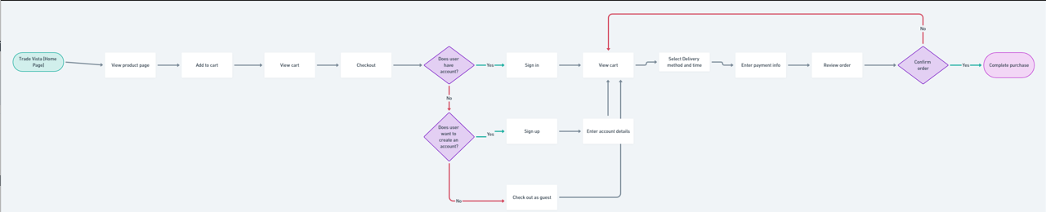

Technology Description

The technologies selected for this project consist of:

- MongoDB: Selected for tracking user profiles, orders, and chef information because of its scalability and versatility in handling a variety of data types.

- React: Chosen for producing responsive and dynamic user interfaces that improve front-end user experience.

- Node.js: Enables server-side programming, guaranteeing effective data flow and interaction management.

- Express.js: Combined with Node.js, Express.js simplifies the process of creating scalable and reliable online applications.

Market Survey

Top-ten technologies from recent job postings include:

1. React

2. Node.js

3. MongoDB

4. Express.js

5. JavaScript

6. HTML5

7. CSS3

8. SQL

9. PHP

10. MySQL

Conclusion

Taking into account the testing phases and feature complexity, an 11-week schedule for project completion has been projected. In addition to meeting academic requirements, this project gives participants real-world experience that will improve their employability in the cutthroat job market.

GitHub Link

[GitHub Repository]https://github.com/amandeepk31/Capstone